CAD Script Creator Tool

Main Window

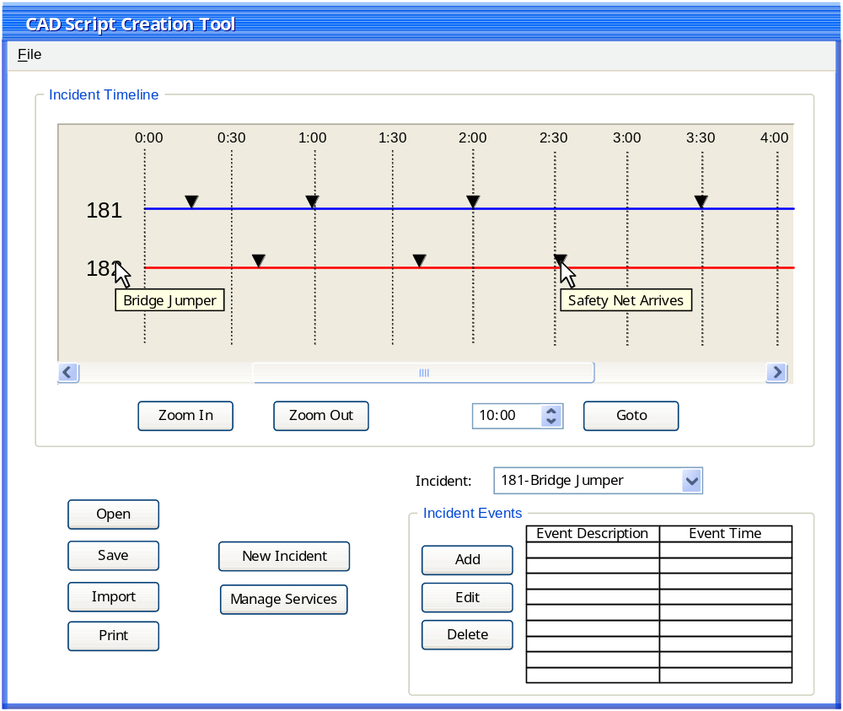

1.1 Features:

Incident Timeline
Each incident in the current script is graphically represented on a timeline. The unique incident number labels each line. A tool tip with the incident description will appear on this label. Along the line are triangles representing incident events, at the time they are scheduled. Each triangle has a tool tip with the event’s description. You may zoom in and out to view a larger or smaller portion of the current timeline. These events may be dragged along the timeline to a new position and rescheduled(icing on the cake, if it’s possible).
Events for an incident are managed in the lower right corner of the screen. When adding new events, the dialog in section 1.1.3 will appear. The table on the main window will show only the event description and time. This is a tabular view of what is on the timeline previously mentioned.
From the main window, the user may open, save, import and print. (These will most likely be in the “File” menu, but are shown on the window to describe functionality).
A new incident is created from the main window and the dialog described in section 1.1.2 is shown.

(Managing available services could be available… This is to be discussed)

1.1.2 New Incident Dialog
When creating a new incident, the following window will appear. The user must enter an incident number and description. Additional attributes are optional.

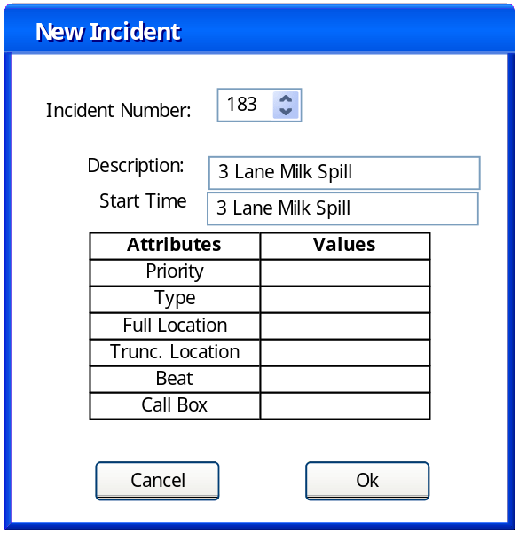

New Event Dialog
When creating a new incident event, the following window will appear. The user must select from an existing list of incidents, and then add a description and event time. An audio file may be loaded into the system, or recorded, but this is optional. The user may add event info, also optional. Event info can be generated from an existing CAD line, or by adding each info type individually. The latter method will allow for more information to be included in the event. Adding in this manner will bring up a separate dialog for each event info type (not yet drawn). The user must also be able to add paramics info. (Also not yet drawn.. it looked like it would be too busy to have it on this window too…. Thoughts?)

